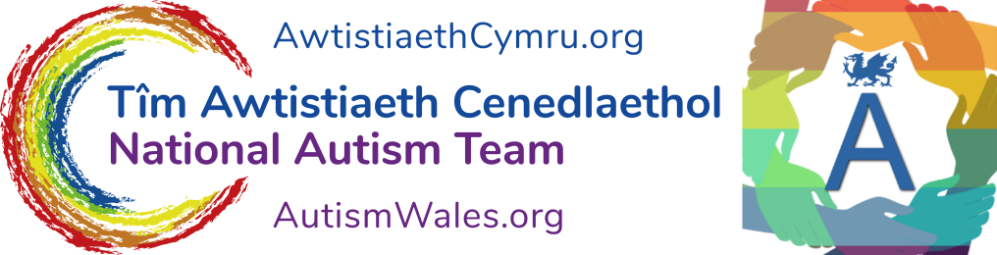

Death and Bereavement

Some thoughts from a NT individual and Psychologist and an autistic friend and colleague.

The death of someone you love is not something you may know how to manage or respond to. This may be the first time you have had this experience and you may not know what to do or say or feel.

You may be struggling to identify how you feel.

You may not have the language to describe your feelings.

The death of this person could lead to changes in your life and this could be hard for you. You may need to make new plans and you may miss the person who has died a lot.

Sometimes writing about difficult or different things like this can help. A lot of people – Neurotypical and Neurodivergent - find death hard to talk about and manage and are not sure what to do. Writing about your situation could help. Sharing your writing with a “reliable” person could also help. What will work for you?

It could help to talk to someone you know who is usually good at helping you think things through and manage. If the person who has died was someone who helped you, this could be very hard. You may need to find a new person or persons to help you. It is okay to seek help and talk about your feelings but find someone reliable.

You may need help to attend the funeral or to manage your finances or home. If you are working, you may need to take time off work or studies. You need to take care to eat properly, exercise, and check you are getting enough sleep as sometimes people can forget to look after themselves when sad or grieving. Be careful not to use alcohol or other drugs to make yourself feel “better” as this is not a good long-term solution.

Sometimes you may feel sad. Sometimes you may feel angry. Your feelings could change quickly and surprise you. It could take time for you to accept that this person has died and what this means for you. Most people do eventually begin to accept the death but it could take longer than you think. If the person who has died has been very ill, you might feel that it is good that they are now longer alive and feeling so ill. Or you could still wish that the person was still alive.

Friends and family members of mine have died and I have experienced feelings of sadness, anger, loneliness and worry. Sometimes, it has taken me a long time to accept these deaths, longer for people I was really close to and really liked. Now it is easier to accept their death as I have got used to their not being around. I have got my memories of them – gifts they gave me, photographs and many stories I can tell about them. I still miss them and feel a bit sad but not as much as I did. It helped me to talk about them. It also helped me to do practical things like making arrangements for the funeral and making a flower bed to remember them.

One of my autistic friends described how they felt when they experienced a bereavement. When their father died they felt no emotions at the time of the death and it felt important to them to continue with their usual day to day routine. They felt emotional much later on - in fact it was about a year later. This was a perfectly fine and natural response for them. The other thing they told me was that they experienced changes in their sensory processing. They noticed smells much more intensely and even felt a bit seasick when walking because of how their vestibular processing system was responding; and their vision was affected for a while too. They worried a bit about whether other people would find their responses unusual, but it is important to remember that everyone experiences grief differently. My friend found it helpful to plan in advance how they would cope with lots of people at the funeral, and the buffet food that would be served because these were things that could add to their distress.

I hope that you find support to help you through this difficult time. If you are feeling very sad or lonely, it could help to get some advice and support from your GP, your family, your friends, a support worker or organisations like this one (Autism Wales) or CRUSE or the Samaritans.

Look after yourself,

Anne Marie McKigney with thanks to Emma Reardon of Autism Wellbeing

More information is available:-

