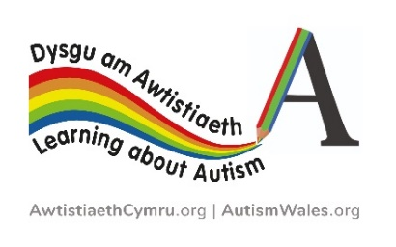

Learning about Autism Primary School - whole school award re-application form

Thank you so much for completing our Learning about Autism programme and for re-applying for this award. To maintain your whole school status, you are required to re-apply for your award every 4 years. It is not necessary for your school to complete the whole programme again, we just want to ensure that those who may have joined the school after you received your award undertakes the relevant training.

The Learning about Autism programmes have been further developed since their inception for example:
- In April 2021 we launched a new online ‘User Dashboard’ has been developed on our website to support you to monitor the progress of your school when working towards achieving the ‘Learning about Autism’ whole school certificate and/or re-applying. Please email us at AutismWales@WLGA.GOV.UK to request your unique username and password
- In October 2019 we relaunched our Autism Aware scheme and we highly recommend all staff who completed any of the above schemes previously should watch the new ‘What is autism?’ film.
- In addition, in 2018 the second edition of ‘The Birthday Party’ film was launched which is based on the SIGNS posters and we also recommend that all staff watch this informative film.

In order to re-apply for the Learning about Autism whole school award please follow the steps below and complete the subsequent form.

- Email AutismWales@WLGA.gov.uk for your school’s unique username and password.

- For nursery classes
- all nursery class staff have completed the Early Years Setting Staff Scheme - Early years setting staff scheme - Autism Wales
- the majority of nursery class pupils have been introduced to ‘Teifi and Friends’ Teifi and friends - Autism Wales

- For Foundation Phase and Key Stage 2
- all new teaching staff have completed the teacher certification scheme - Teaching staff training - Autism Wales
- all new learning support staff have successfully completed the LSA certification scheme - Learning support staff - Autism Wales
- all new other support staff (including midday supervisors, admin staff and governors) have completed the ‘Autism Aware’ scheme – Autism aware certification - Autism Wales
- the majority of all new KS2 pupils have signed the Autism Superhero Pledge – Autism superheroes - Autism Wales
- practice continues to be autism friendly in the school

- Please fill in the below form and we will be able to check the completion rates for your school and re-issue your certificate.
School name
Head teacher name
Email
Local Authority
Number of nursery class staff that have completed the Early Years Setting Staff Scheme
Number of nursery class pupils
Number of nursery class pupils introduced to ‘Teifi and Friends’
Number of new teaching staff that have completed the Teaching Staff certification scheme
Number of new learning support staff that have completed the Learning Support Staff certification scheme
Number of new other support staff that have completed the autism aware scheme
Number of pupils within the school
Number of new KS2 pupils that have completed the Autism Superhero scheme

- Describe the environmental changes that you have created over the last 4 years following the completion of the programme

- Describe the changes to teaching approaches over the last 4 years following the completion of the programme

- Please provide any positive case studies resulting from completing the programme within your school.

- Are you in agreement for the National Autism Team to use the school’s name and above comments for future publicity of the Learning about Autism programme and/or case studies?

Yes ☐ No ☐

