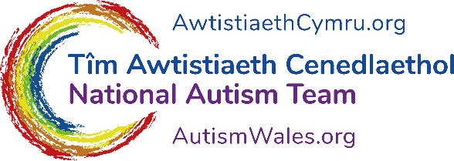
Easy Read Survey

Online employment event survey

We want to know what you think

This survey was written by the National Autism Team. It is an easy read version of ‘Virtual employment event survey’.

June 2021

About this survey
 | Hello! We are the National Autism Team.
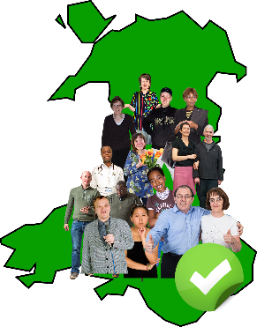 | We work to improve the lives of autistic people, and their families and carers across Wales.
 | We are planning to hold an employment event for autistic people. And for autistic people who also have a learning disability.
 | The event will be in December.
 | We are working with Learning Disability Wales to make sure everyone can easily join in with our event.
 | We are working with autistic people to plan the event too.
 | If you want to help us plan the event, please give us your e-mail address so we can contact you. We will only use this address for help with planning the event.
 | Your e-mail:
 | We will use the answers we get in this survey to help us plan the event.
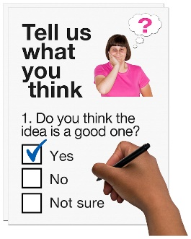 | We would really like your views. Please answer the questions in this short survey.
 | If you have any questions, or would like to talk to us about your views please e-mail us at AutismWales@WLGA.gov.uk
 | This survey was made into easy read by Easy Read Wales using Photosymbols.

Questions
 | - Do you have a job? Please tick the box that best describes your situation.
 | I work part time | ☐
 | I work full time | ☐
 | I am a carer – part time or full time | ☐
 | I am retired | ☐
 | I am unable to work | ☐
 | I am looking for a job | ☐
 | I am a student – part time or full time | ☐
 | I am doing an internship or an apprenticeship | ☐
 | I am a volunteer | ☐

An Apprenticeship is when a person learns the skills of a job whilst working.

An internship gives students the chance to get work experience.

- What things from the list below do you feel are most important to learn more about?

Please choose up to 4.
 | Finding a job that’s right for me | ☐
 | Applying for a job | ☐
 | Planning for an interview and doing an interview | ☐
 | Talking to your employer about my needs | ☐
 | Dealing with stressful situations at work | ☐
 | Organising your time and working to deadlines | ☐
 | Understanding my rights at work | ☐
 | Applying to university or college | ☐
 | How to tell my employer I am autistic | ☐
 | How to look after my mental health | ☐

- What things from the list below do you find easiest to learn from?

Please choose up to 3.
 | Workshops run by other autistic people | ☐
 | Listening to people talk | ☐
 | Doing practical activities like a short piece of writing | ☐
 | Reading short pieces of writing | ☐

 | - We would like people to take part in the event as much as possible. What kinds of activities would you like to take part in? Please tick all the activities you like.
 |  | Quizzes or voting in polls | ☐
 |  | Small group talks in breakout rooms | ☐
 |  | Question and answer sessions | ☐
 |  | Practical activities like a short piece of writing | ☐
 |  | Watching videos | ☐
 |  | Listening to podcasts (Audio files that you can listen to any time. Usually of someone speaking) | ☐

 | - Would you like us to keep in contact with you to tell you about the event? We will tell you how to sign up and when it will be.
 | Yes. My e-mail address is: | ☐
 | Yes. My postal address is: | ☐
 | No | ☐

