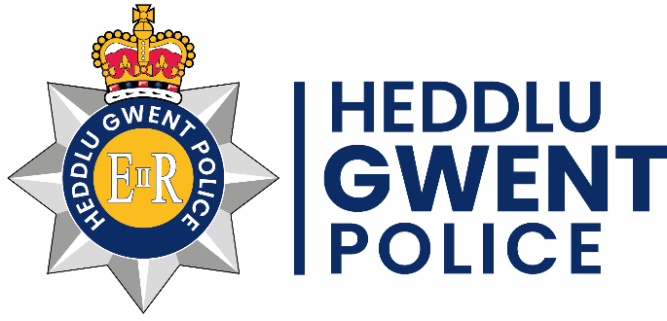
Gwent Police
Trinity Protocol - Frequently Asked Questions (FAQs)

Since the release of the Trinity Protocol, we have received a great amount of positive feedback on how it helps our vulnerable members of the community. However there are questions often asked about the protocol, forms, access to it, etc. and there can be some confusion.
This document will answer your most frequently asked questions, it should help you in understanding the Trinity Protocol and completing the form.

Q. What is the Trinity Protocol?
The Trinity Protocol is a database for persons with additional needs such as Autism, Global Delay, ADHD, Learning Difficulties, etc. They provide key information to Gwent Police where our frontline officers can use this information to provide the best appropriate response if they are involved with an incident.

Q. Is there an age limit?
No, there is no age limit for a person with additional needs. This means any person with an additional need is applicable for the Trinity Protocol.

Q. Can I submit a form for a family member, friend or other associate?
If the person with additional needs has capacity, it is ultimately their decision if they wish to be on the Trinity Protocol. If the person with additional needs does not have capacity, an appropriate adult can submit a form. This can be a parent, guardian, carer, etc. However it is important that you involve the person with additional needs in the process as much as you can.

Q. Will the information provided be safe and secure?
Yes all information on the form will be safe and secure. It will be stored as its own version electronically and we will store this on our force system known as NICHE.

Q. Does the person on the form have to be missing previously?
No, the person with additional needs does not need to have been missing before. Again any person with an additional need is applicable for the Trinity Protocol. If they have been missing before or involved in criminal activity, it is important that this is highlighted in the form. However they can be on the Trinity Protocol just for their safety and you can feel comfortable knowing Gwent Police have their key information if they are every involved in an incident.
Q. Do I have to fill out all the information on the form?
No, you do not have to provide all the information on the form. Some questions are marked optional as they can be intrusive but we encourage you to complete as much as you can on the form. The more information we have on the person with additional needs, the more appropriate our response can be to them.

Q. What type of photograph is best to use?
The most recent photograph of the person would be the best option. However you do not need to have a photo from a passport or one which is done professionally. As long as it has a clear view of the person’s face, it can be taken from a mobile phone, digital camera, etc. We do accept physical photographs but for ease of access, the photograph should be sent via email or scanned across.

Q. If I live in a different force area, can I still complete the form?
If the person on the form frequents or is known to stay in the Gwent area, yes they can be put on the Trinity Protocol. However this has not been rolled out into other police forces yet and they would not have access to this information. For example if the person lives in the South Wales area but attends school in the Gwent area, they are applicable. If they solely stay in the South Wales area, they are not applicable at the moment.

These are the most frequently asked questions however we understand that certain points may not have been covered. Please contact the Crime Prevention team via email at crime.prevention@gwent.police.uk if you have any further questions or concerns regarding the Trinity Protocol. A member of the team will get back to you and help explain any issues you may have.

