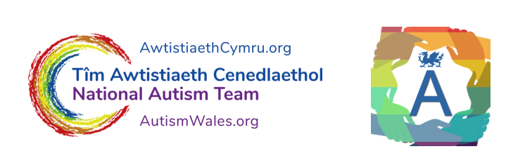
Returning to School
Spring Term 2021

School and local authority staff have been preparing and planning to reopen schools for all learners after the Easter holidays.

Some parents are worried about sending their children back to school, some children are also worried about returning. Others are really looking forward to returning. If your child has autism or needs additional help in school, returning and preparing to return could present some challenges but possibly some opportunities.

This is a time for you to think about and plan for your child to return to school. If your child is old enough, involve your child as much as you can in this planning.

Resources & website links

There are lots of resources and videos already available that can help you to think about and plan this, please see below:

- Your child’s school and the local authority can also help you plan. The school may have already contacted you to talk about this.

- There are voluntary organisations who can also help you. Family and friends may also be a good source of help and support.

- If your child has particular health needs you may want to talk with a health professional you know well about returning to school e.g. GP, Health Visitor, Paediatrician.

Stars Team – Coronavirus Resources
http://www.starsteam.org.uk/coronavirus-resources

Reach Out ASC – Coronavirus, home & School and Transition resources
www.reachoutasc.com/resources/transition-to-new-class

Twinkle
www.twinkl.co.uk (you will need to create an account to access these resources)
https://www.twinkl.co.uk/resource/returning-to-school-social-situation-t-s-2548814

Elsa Support
www.elsa-support.co.uk/category/free-resources/coronavirus-support
www.elsa-support.co.uk/back-to-school-after-coronavirus-story
www.elsa-support.co.uk/downloads/separation-anxiety-item-371 (£3.50 charge)

Social Stories
www.carolgraysocialstories.com/social-stories

TEACCH
www.teacch.com

Please see the following 10 tips which could help you and your child in returning to school:

- Talk about it – Talk to your child about returning to school and explain clearly and simply what will happen. Remember to continue talking to your child about this after he/she returns to school, but choose your times! Make sure you explain in a way your child understands. Using pictures and symbols could help, what works best for your child.

- Identify positives, possible problems and solutions – What will be good about returning to school? What could be difficult? What are you hoping for? What is your child hoping for in returning to school? And school staff?

- Plan for now and for later – You will need information from school to develop a plan and make preparations. You may need to modify your plan depending on how the return goes and as the situation changes. COVID 19 has brought many changes and could bring more.

- Work together with your child, family and school staff – This will increase the chances of a safe, successful return. It is really important that everyone agrees to and is aware of the plan and this plan is monitored and reviewed. Share with school your child’s achievements and experience of “lockdown”.

- Develop useful routines – Start practising now. You may need to start going to bed earlier and waking up earlier. You may need to start wearing different clothes, changing mealtimes. If you’ve been using a schedule you will need to change it, if you haven’t been using a schedule, think about using one. Make sure your schedule contains quiet times for relaxation and some exercise. Using pictures and symbols should clarify and increase predictability helping to reduce anxiety.

- Set a clear countdown for return – Consider using a calendar and visual prompts to remind yourself to work towards returning. Social stories or social scripts could also help. Some children will need a lot of details and explanations, others will not. Consider how much detail and preparation your child will need. Try to involve school staff in this especially if there has been limited contact with school.

- Check in with yourself and your child – How are you doing? How are you feeling about this? You could use a set of symbols or emojis to check in with your child. Remember feelings can fluctuate during the day and it is useful to monitor this. You may need to carry on checking how your child is feeling for quite a long time. This is probably a good habit to develop.

- Prepare for “The New Normal” – Is it possible to see the new physical arrangements – the classroom set up, entrances, exits, hand washing facilities and physical distancing boundaries/markers. How will your child get to school? Will your child need to bring sanitizer, face masks or their own pens and pencils? What about lunchtime – snacks and drinks? Is there a quiet area available? What will remain the same? There are lots of things to check out. Hopefully the school has addressed many of the general issues around safety and functioning, but you may need to enquire further.

- Settling into school again – It may take a long time to settle in again. Allow for this. Allow time to relearn, recover and settle in. Recognise that there may be changes to staff and class composition. Your child may miss some things from their previous experience of school. You may have experienced the loss of a friend or a family member. Be kind to yourself and your child.

- Hopes for the future – Do what you can do now to make sure school is the best place it can be for your child as he/she returns. Remember to celebrate your achievements whilst not at school and what was good about being at home together. Keep that going when your child returns to school.

Anne Marie McKigney
Consultant Child and Adolescent Psychologist
Aneurin Bevan University Health Board
March 2021

Click on the icon below to play the audio file for this document:

