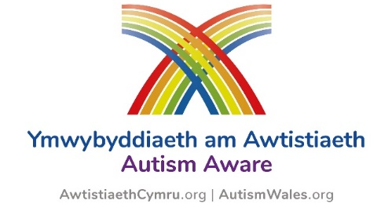

Application for Autism Aware Organisation Status

Organisation / Service title
Areas covered
(this information will be used to place organisations in the Directory of “Autism Aware organisations” – please tick more than one if applicable)
Local Authority Area
All Wales |  | Denbighshire |  |  |  |  | Pembrokeshire
Blaenau Gwent |  | Flintshire |  |  |  |  | Powys
Bridgend |  | Gwynedd |  |  |  |  | Rhondda Cynon Taf
Caerphilly |  | Isle of Anglesey |  |  |  |  | Swansea
Carmarthenshire |  | Merthyr |  |  |  |  | Torfaen
Cardiff |  | Monmouthshire |  |  |  |  | Vale of Glamorgan
Ceredigion |  | Neath & Port Talbot |  |  |  |  | Wrexham
Conwy |  | Newport
Health Board Area
Aneurin Bevan Health Board |  | Betsi Cadwaladr University Health Board |  |  |  |  | Cardiff & Vale University Health Board
Cwm Taf Morgannwg Health Board |  | Hywel Dda Health Board |  |  |  |  | Swansea Bay University Health Board
Powys Teaching Health Board
Certificated on-line scheme(s) completed
Autism Aware |  |  |  | Leisure Scheme
Health & Social Care (Adults) |  |  |  | Employment Scheme
Health & Social Care (Childrens) |  |  |  | Human Resource Scheme
Housing scheme
Details of organisation
(optional – but will be used in the ‘Autism Aware organisations’ section to promote the organisation if desired)
Number of people in organisation with direct contact with individuals*
(please note it is expected that 100% of staff successfully complete the scheme if there are less than 25 team members, 80% if more than 25 team members)
Number of people in organisation who have successfully completed the Autism Aware certification scheme
Name of organisation as recorded in the Autism Aware scheme
(i.e. all staff members should enter same details in the company / service section of the Autism Aware certification form)
Contact Details
(please include at least one name and an associated e-mail address)
Additional info / feedback

Complete this form and email to AutismWales@WLGA.gov.uk to receive your personalised organisation certificate.

*Please contact the National Autism Team to discuss if your organisation is particularly large / complex as there is potential for a graduated approach this scheme a department at a time.
We look forward to hearing from you.

