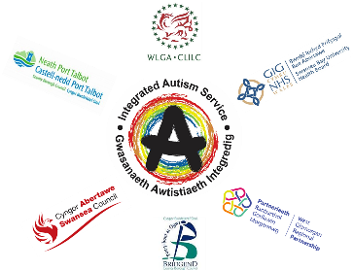

Western Bay Integrated Autism Service
Virtual Autism Advice Sessions
Western Bay Integrated Autism Service is working hard to find alternative methods of support in these uncertain times of lockdown and social distancing. Instead of our usual face to face Advice Hub sessions, we would like to offer a Virtual Autism Advice Session.
During the session you will be able to discuss any issues relating to Autism. The advice session will be run by two of our Wellbeing Support Workers.

When?
There will be four sessions available each Thursday. Each session will last for a maximum of 30 minutes. All appointments will be booked on a first come, first served basis.
Autism Advice Sessions will be available Thursdays:
9:30am, 10:30am, 11:30am & 1:15pm
How?
We will offer an individual virtual appointment using Attend Anywhere. The advice session will be confidential. Guidance will be made available to support you to access Attend Anywhere. You will need to be able to access an electronic device that has internet connection.
At the time of booking we will need your name, email address and phone number so we can contact you in case of any problem with IT access. We will also ask if you could give a brief description of what you would like to discuss.

If you would like to seek autism related advice from us, but are not comfortable with a virtual appointment or the use of Attend Anywhere we can offer a telephone session.
To book a session or for further information, please contact us on:
01639 862936 or
sbu.WBIAS@wales.nhs.uk

