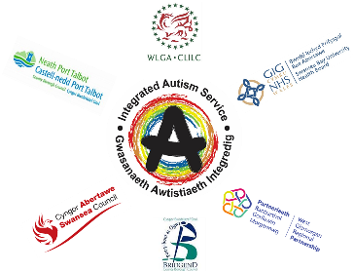

Western Bay Integrated Autism Service
Virtual Autism Advice Sessions
Slots available to book (up to 30 minutes)

When? Every Thursday - 9:30am, 10:30am, 11:30am & 1:15pm
What? This is advice for everything autism related
What do I need? SMART phone or laptop, webcam, secure internet connection.
Who? Sessions are open to anyone in Swansea, Neath Port Talbot & Bridgend, 18+, with or without an Autism diagnosis
Who is it with? There will be two Wellbeing Support Workers present
How? Phone 01639 862936 or email sbu.WBIAS@wales.nhs.uk to book

If you would like to seek autism related advice from us, but are not comfortable with a virtual appointment or the use of Attend Anywhere we can offer a telephone session

