Our Team
Local team information

Contact Us
Local Team Contact Information

8

Assessment for Autistic Spectrum Disorder (ASD)

  - Information for Parents and Carers of Children

Your child has been referred for an assessment for Autistic Spectrum Disorder. This leaflet give an overview of what to expect during the assessment process.
1

What is an Autistic Spectrum Disorder?

ASD is a developmental condition which affects 1 in 100 people. ASD is a lifelong condition, which means there is no cure and children do not ‘grow out’ of it. However, with the right support children with an ASD can be supported to reach their full potential. There are many famous people with ASD, and people with an ASD can have great jobs, relationships and families.

The way in which ASD affects a child varies, but common signs include:
Delay in using, or limited use of language. | Repeating phrases from others, or television. | No interest in peers. Not seeking or offering comfort.
Unusual sensory responses. | Unusual eye contact.  No social smile. | Lack of emotional gestures.
 | 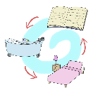
No imagination or imaginative play, or not sharing imaginative ideas with others. | Prefers familiar routines. Displays repetitive behaviours or movements. Arranges objects in patterns or lines. | Does not point to show interest.  Does not share interests with others.
Many children without ASD display some or all of these behaviours at times, a professional will need to assess whether the child has ASD or not.
7

2

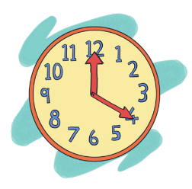
Appointments
7

2

You can use this space to keep a record of your appointments.
Name | Venue | Date | Time
ASDinfoWales Resources
www.ASDinfoWales.co.uk is the National website hosted by the National ASD Development Team within the WLGA in partnership with Public Health Wales and funded by Welsh Government. The website provides information and resources for individuals with ASD and those supporting them. Amongst other resources you will find:

Parent Carer Films
These high quality short films provide a basic overview of ASD and provide advice on how to adapt communication, support planning and manage difficulties around coping with changes. There is also a short film which provides advice to make visits to the clinic or healthcare setting less stressful.

Autism: A Guide for Parents and Carers Following Diagnosis
This guide is aimed at parents and carers of children and provides information, advice and guidance from professionals and parents / carers.

Picture Cards
A simple, interactive resource, where you can search, select, download and print from a series of bilingual picture cards, to create a structure chart.

Child Profile
An online interactive tool leading to downloadable profile of a child’s strengths and difficulties

Autism Superheroes

For siblings there is an adventure comic-strip, featuring positive role models for children and an online pledge, leading to an Autism Superhero Certificate.

For further information visit www.ASDinfoWales.co.uk
6

The Assessment Process

There is no medical test for ASD, instead professionals will explore your child’s strengths and difficulties in various areas and use this information to decide whether they meet the criteria for a diagnosis.

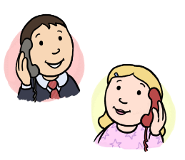
Professionals

Many professionals are involved in the assessment. You may be seen by more than one professional. Professionals may include doctors, nurses, psychologists, speech and language therapists and occupational therapists. With your permission, these professionals may also gather information from other professionals who know your child including school staff, health visitors and others.

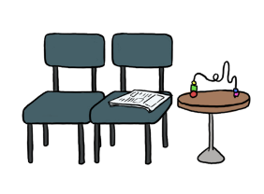
Venues

The assessment may include a variety of meetings in different settings. You will usually be asked to attend more than one appointment at clinic or hospital settings. Some parts of the assessment may be carried out at your home (with your permission) or in your child’s school or nursery. This is so that professionals can see how your child copes in different settings.
3

Timescales

As each child is different, so is the assessment. An assessment will take at least a few months to complete, however the amount of information available and the range of difficulties can affect the time an assessment takes. A professional will provide you with estimated timescales and keep you updates of any changes.

Gathering Information

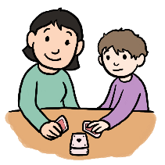
You will be asked to share information about your child with professionals. This will include any issues or concerns you may have. Sometimes this is done informally, by a professional discussing your child with you. At other times this may be more structured and may include you answering structured questions or completing questionnaires or behaviour diaries. As mentioned earlier, information will also be sought from others who know your child.

Your child’s strengths and difficulties will also be directly assessed. This may be through a professional observing your child, talking to or undertaking activities with them. The assessment is not unpleasant for your child, and every effort will be made to put them at ease.
4

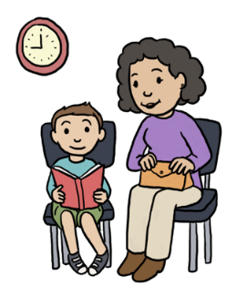
Feedback

After the assessment is completed you will be invited to a meeting with one of the professionals who was involved. You will provided with the outcome of the assessment, and advised of your child’s strengths and difficulties and how best to help them.
You will also be given written feedback. With your permission, others involved with your child will also be given this information to help them to support your child in the best way.

Support

The professionals involved in the assessment will provide you with advice and information about how to understand and support your child. They will also make arrangements for ongoing support based on your child’s needs. This may include providing you with details of support groups, offering short term interventions or referring your child to another professional for support.

5

