- We are quite nosey, so the fifth thing you need to know is:
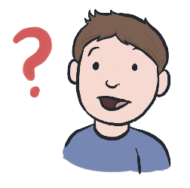

We will ask you questions about you,
there are no right or wrong answers!

- Finally, because you might still be a little bit worried, the last thing you need to know is:

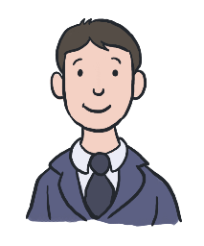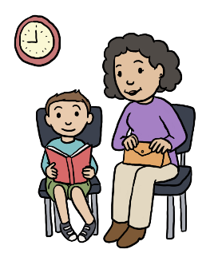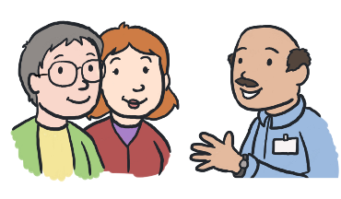
An adult that you know can stay
with you when you meet us!
4

Welcome to Our Service
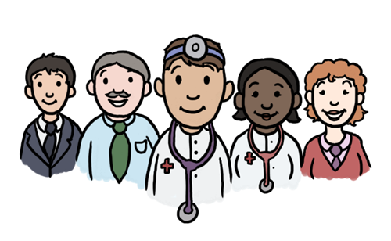

  - Information for Children
(Here are 6 things you need
to know about us!)
1

Why am I having an assessment?
Somebody who knows you well has told us that you are having some difficulties. These difficulties may be at home or school or both. We would like to find out more about you so that we can help you.

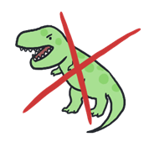
- The first thing you need to know is:

We are not scary!

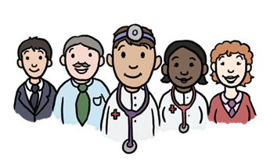
- The second thing you need to know is:

We are a team, so you will meet
more than one of us!
2

- We like to learn about the things you do, and do not, enjoy. The third thing you need to know is:
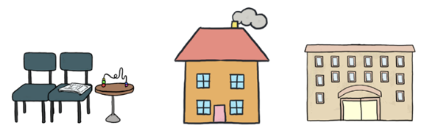

You will come to visit us at our clinic, but we might also visit you at home or school.

- You might think it will be boring, so the fourth thing you need to know is:
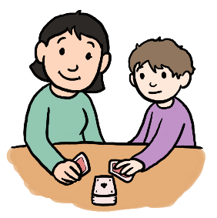
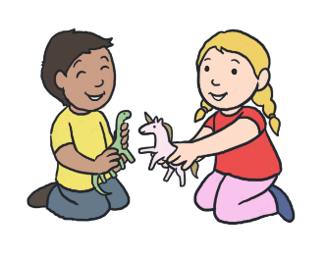

We like to play and we have lots of fun things
we can share with you!
3

