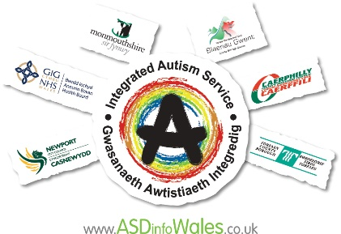

Gwent Integrated Autism Service
Virtual Autism Advice Sessions

Gwent Integrated Autism Service are continuing to work hard to find alternative methods of support in these uncertain times of lockdown and social distancing. Instead of our usual face-to-face drop in sessions, we would like to offer a Virtual Autism Advice Session.

During the session, you will be able to discuss any issues relating to Autism, in the same way you would at our drop-ins. The advice session will be run by two of our support staff, our new Peer Mentor Worker will also be present in the background.

We will offer a face-to-face virtual appointment using Microsoft TEAMS. The advice session will be confidential. The use of Microsoft TEAMS is fully compliant with GDPR and Information Governance policies of ABUHB and Monmouthshire County Council. Guidance is available to support you to access Microsoft TEAMS.

At the time of booking we will need your name, email address and phone number so we can contact you in case of any problem with IT access. We will also ask if you could give a brief description of what you would like to discuss.

Slots available to book (up to 45mins)

When? Every Tuesday – 10.30am, 11.30am, 1pm & 2pm

What? This is advice for everything Autism related

What do I need? SMART Phone or laptop, webcam,
download TEAMS app, secure internet connection

Who? This is open to anyone in the Gwent area, 18+
(with or without a diagnosis of Autism)

Who is it with? There will be two Support Workers and our Peer Mentor present

How? Just call our office number or email to book:

01633 644143 or asdservice.abb@wales.nhs.uk

If you would like to seek autism related advice from us, but are not comfortable with a virtual appointment or the use of TEAMS, please remember we are available Monday – Friday 9am – 4pm on the above telephone number or email address.

