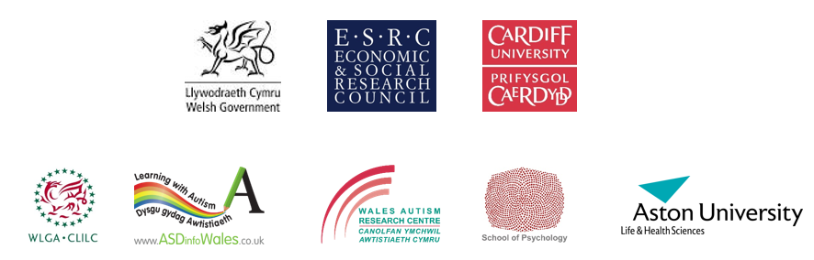

Permission to use the Birthday Party: a film about the SIGNS of autism in children
Welsh Government/ Cardiff University 2017

The film The Birthday Party was joint funded by the Welsh Government and Cardiff University (Economic and Social Research Council Grant) and was written and produced by Jo Manikiza and Sue Leekam with partners Sarah Carrington (Aston University) and Judith Gould (Lorna Wing Centre). Its development was based on Cardiff University led research (see publication reference link below). This research publication also provides information for the signposting posters on the film’s web page.

The Open Government Licence allows people to use the material for free for training or other purposes as long as they acknowledge the source and make clear that it is a free resource. The film should be referenced or embedded by including this link www.asdinfowales.co.uk/autismchildsigns and acknowledging the sources of Welsh Government and Cardiff University.

Agreement for the use of The Birthday Party: a film about the SIGNS of autism in children

I agree to credit in writing The Welsh Government and Cardiff University when recommending or showing the film and advise that it is a free resource. I also agree to provide a reference to its source publication as follows: Carrington, S.J. Leekam, S.R. et al. 2015. Signposting for diagnosis of Autism Spectrum Disorder using the Diagnostic Interview for Social and Communication Disorders (DISCO). Research in Autism Spectrum Disorders 9, pp. 45-52. (10.1016/j.rasd.2014.10.003).

I agree to be contacted by email in 12 months to review whether the film is still being recommended and if so, to which groups of professionals/parents.

Name: …………………………………………………………………………………………………………...

Organisation/ Affiliation: ………………………………………………………………………………………..

Please return to: Dr Catherine Jones and Prof Sue Leekam, Cardiff University using this email address
jonescr10@cardiff.ac.uk and put “permission form” into the header of your email.

