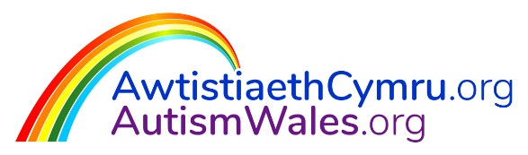

Accessibility Information for
AutismWales.org / AwtistiaethCymru.org

- Background to ASDinfoWales.co.uk
In 2019, the National Autism Team (NAT), Welsh Local Government Association were given notice by their ‘ASDinfoWales.co.uk’ website providers. What followed was a transparent procurement process and the NAT awarded the tender to Oxygen Agency Ltd. in March 2020 to;
- migrate the existing website over to their server, and
- build a new website that would be more intuitive, accessible, and modern.

The voice of autistic people was considered from the very beginning of the project, where the NAT conducted an online website survey via the Team’s social media platforms (www.facebook.com/ASDinfoWales/ and https://twitter.com/ASDinfoWales) in 2019/ 2020. This provided the Team with initial user feedback on the ease of use, clarity of information, presentation of information, and overall quality of the website. The full report is available to view here:

New Provider
Oxygen Agency Ltd. run standard checks on their websites which include W3C compliance. New developments of the website will be tested through WAVE, a web accessibility evaluation online tool (https://wave.webaim.org/).

Oxygen Agency Ltd. also have certificates for the following standards:
- ISO9001:2015, which is the international quality standard.
- ISO27001:2013, which is the international standard for information security.

- Stakeholders and Engagement
The NAT established two Stakeholder Groups once the new website provider had been appointed, as well as a Project Team and Project Board. These groups meet regularly and include input from autistic people, parents/ carers, Local Authority Autism Leads, Health professionals, and representatives from the NAT, Welsh Local Government Association (WLGA), and Welsh Government (WG). Further information on the roles of each group can be found here:
The Stakeholder Groups ensure that the voice of the website user is at the heart of every decision that is made regarding the new website. Some examples of the constructive comments given by members of the “Content” Stakeholder Group and the Project Board have been captured below:
- Autism Superheroes Animation – concern showed about the possible voice-over “due to some autistic people struggling with processing time”.
- Website background colour filter options – “pale blue and lavender background colour filters are often popular options for autistic people, and my husband can only read from a pale blue background”.
- Website background colour filter options – “my wife has a visual impairment, and the black background with yellow text could be deleted, because it is similar to the black background and white text, without having the same effective contrast, so it’s more difficult to read”.
- Decision to not have pictures in the banner image – the Group decided on Option 1 (without a picture), because it is “simpler, clearer, easier to understand, and less busy”, the “people using the site are less likely to be distracted as they might be by pictures”.
- Feedback concerning the meetings themselves – “The meetings are easy to follow and have a good pace to them.” / “It is impressive to see the amount of opinions coming from many different people.” / “Nobody is being overlooked within the group and the visuals keep the meetings very engaging.” / “It’s great to have a platform which allows people to feedback honestly and critically on the work.”

- Accessibility Improvements and Developments to refreshed website

Adjusting Text Size
Users are able to modify the size of the text by using the on-screen text adjuster at the top of the page - this allows the user to choose if the text on each page is displayed as small, medium or large in size.

Users can also modify the size of the text on the website by adjusting this selection within the settings of their browser.

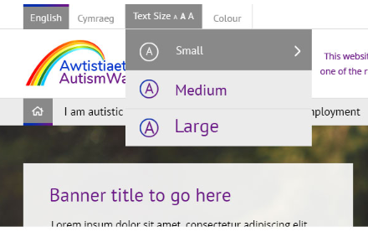

Colour Filters
Users are able to adjust the colours displayed on-screen by selecting from a variety of colour filter options available from a drop-down menu at the top of the page. The available colour filter options include:
- Standard – Dark Blue/Indigo Background with White Text
- Black Background with Yellow Text
- Black Background with White Text
- Green Background with Black Text
- Lilac Background with Black Text
- Yellow Background with Black Text
- Blue Background with Black Text
- Greyscale – Grey Background with Black Text

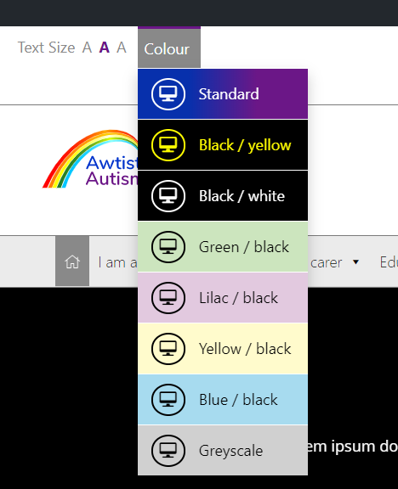

The various colour filter options were added after the NAT conducted a social media poll in July 2020, asking their followers to confirm which colour filters they prefer to use when browsing the internet. The feedback received from this poll suggested that a “lilac background with black text” was the most popular option, followed by “muted yellow background with black text” and “black background with white text”.

 | Votes
Lilac background with black text | 3
Muted yellow background with black text | 2
Black background with white text | 1
Green background with black text | 0
Other | “prefer no filter”

The full report of the feedback received is available to view here:

As a result, the new website provides more accessibility to the user in terms of colour choices. It should be noted that the web-site Stakeholder Group recommended the choices be limited to a fixed number of colour options, to avoid risking overwhelm, or anxiety by having too many choices for the autistic user.

Accessible Language
The NAT will continue to operate a bilingual website by ensuring that it is accessible to both Welsh and English speakers.
Some external/ third party documents have been shared on the website which may only be available in English. However, where possible, Welsh iterations of external documents will be shared.
Users can choose their preferred language by selecting the Cymraeg / English language option at the top left of the screen.
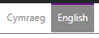
Subtitles
The NAT will continue to improve the accessibility of the resources through a rolling programme to make Welsh and English subtitles available on all films on the website.

This has been a priority for the NAT since February 2019.

Users can enable subtitles by clicking the ‘CC’ button in the embedded Vimeo link, and then selecting ‘Cymraeg’ or ‘English’, dependant on which language they are viewing the film in.

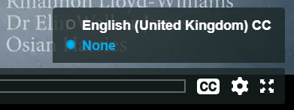

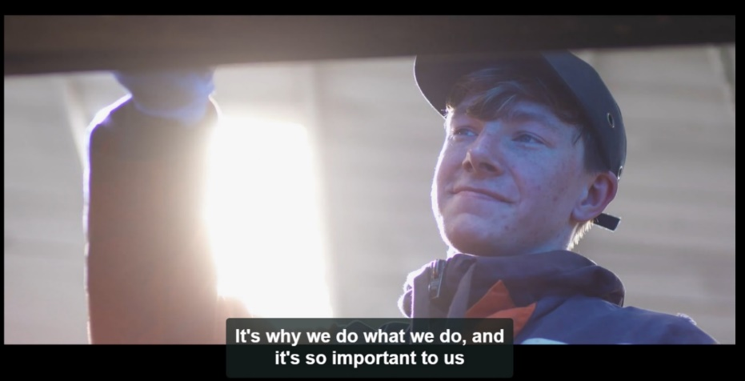

The following films are currently available in this accessible format:
- Can You See Me?
- What is Autism?
- Work Based Learning Film

The following films are scheduled to be updated with this accessible format:
- Further Education Film
- Early Years – Staff Film
- Early Years – Teifi Film
- Primary – Introduction Film
- Primary – Teacher Film
- Primary – LSA Film
- Secondary – Introductory Film
- Secondary – Teacher and LSA Film
- Secondary – Sgilti
- Parent/ Carer Film
- Getting to know Gerraint

Further accessibility features to follow:
- ‘Easy Read’ versions of resources will be available on the new website, which we will progress in conjunction with Learning Disability Wales.
- A new ‘Children and Young People’s Zone’ will be a feature of the website: filtering accessibility based on age-appropriate information.

