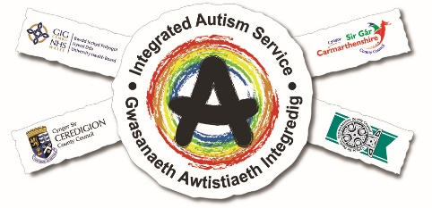
West Wales Integrated Autism Service
Virtual Autism Information Hubs.
NEW for 2020
The West Wales Integrated Autism Service (WWIAS) are pleased to be able to offer a new opportunity for individuals to gain autism related support. We will be running our information hubs virtually for the foreseeable future. They will be run through the media of MICROSOFT TEAMS. The use of Microsoft Teams is an approved platform by Hywel Dda health board and is fully compliant with GDPR and Information Governance policies.
These sessions will be a private support session where you can discuss difficulties and what matters to you confidentially. The sessions will be run by an autism specialist clinician and an autism specialist support worker. Guidance will be made available to support you to access Microsoft TEAMS. You will need to be able to access an electronic device that has internet connection.
At the time of booking we will need your name, email address and phone number so we can contact you in case of any problem with IT access. We will also ask if you could give a brief description of what you would like to discuss.
To find out more about the Integrated Autism Service or to book a 45 minute virtual appointment and talk to us about how autism affects you and your family please contact us…
Email: Westwalesias.hdd@wales.nhs.uk
Telephone: 01267 283070
If you don’t feel comfortable using TEAMS, then please let us know and a telephone slot can be booked instead.

The sessions will take place every Wednesday for the foreseeable future until lockdown restrictions ease.
There will be 4 slots available every Wednesday.
Private Consultations time slots are:
10am 11am 1pm 2pm
Book a slot now and talk to a member of the IAS team confidentially.

