National Autism Team resource & training films
available at ASDinfoWales.co.uk

General Schemes / Resources / Training films:

- What is Autism?
A film designed to raise awareness and understanding of autism, enhancing our Autism Awareness & Understanding certification scheme
www.ASDinfoWales.co.uk/asdaware

- Can You See Me?
Part of an awareness scheme launched to promote understanding and acceptance of autism amongst communities in Wales
www.ASDinfoWales.co.uk/can-you-see-me

- Getting to know Gerraint
As a Team, we are dedicated to working co-productively with autistic individuals, parents/ carers and professionals across Wales, and Gerraint is one of many examples of somebody who provides an excellent role model for young autistic adults
www.ASDinfoWales.co.uk/xxxxx

- National Autism Wales Conference
Film footage from our successful conference held in April 2019 is available online, which includes information from our keynote speakers, Emma Durman, “The Winding Road of Wellbeing: postcards from my journey”, and Jules Robertson, “My Journey into Actor”
www.ASDinfoWales.co.uk/nawc2019

- The Birthday Party - SIGNS
This film has been designed to help front-line professionals to identify the signs of autism in children. We designed it to be suitable for professionals working in education, healthcare and social services, as a supplement to a training session
www.ASDinfoWales.co.uk/autismchildsigns

- Emergency Services
This film has been designed to help front-line emergency services to identify autistic individuals and provide information on how to adapt their day to day practice, in collaboration with emergency service providers
www.ASDinfoWales.co.uk/emergency-services

Parent / Carer Films:

- ASDinfoWales TV
This film provides an overview of autism and what resources are available following a diagnosis
www.ASDinfoWales.co.uk/tv

- Growing with Autism
A series of films that provide information & advice on themes such as communication, coping with change, planning and visiting health professionals
www.ASDinfoWales.co.uk/asd-videos-for-parents-carers

- Living with Autism
This film aims to increase understanding, showing what life can be like for an autistic adult
www.ASDinfoWales.co.uk/living-with-autism-film

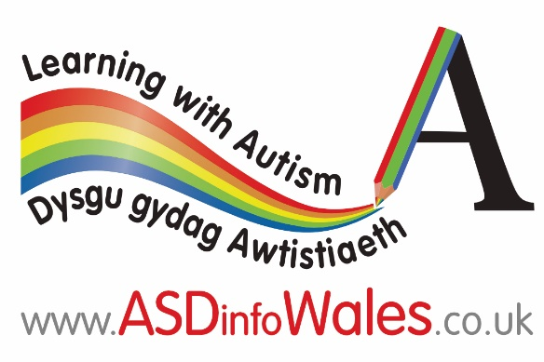
Education Training Films:

- Early Years Settings
A staff training film and certification scheme
www.ASDinfoWales.co.uk/early-years-setting-staff-scheme

Teifi & Friends
Short animation showing how children can be kind and accepting towards peers with additional needs
www.ASDinfoWales.co.uk/teifi-and-friends

- Primary Schools
A teaching staff training film and certification scheme
www.ASDinfoWales.co.uk/teacher-staff-training

A learning support staff training film and certificated scheme
www.ASDinfoWales.co.uk/learning-support-staff

- Secondary Schools
A teaching and support staff training film and certificated scheme
www.ASDinfoWales.co.uk/secondary-school-teaching-and-support-staff-scheme

Sgilti Lesson
A training film and pledge for pupils and peers to undertake
www.ASDinfoWales.co.uk/sgilti-lesson

- Further Education
“What is Autism?” and Further Education training film, providing information and examples of good practice, as we follow students’ journey whilst in college
www.ASDinfoWales.co.uk/further-education

- Work Based Learning
“What is Autism?” and Work Based Learning training film, providing information and examples of good practice as we follow two learners’ journey whilst completing their worked based learning placements
www.ASDinfoWales.co.uk/work-based-learning

Employment Film:

- Working with Autism
A film to increase knowledge and awareness of the needs of autistic individuals and those who are supporting them to secure employment
www.ASDinfoWales.co.uk/working-with-autism-scheme

Available with subtitles, all films will be more accessible during 2020/21
Available with subtitles, all films will be more accessible during 2020/21

