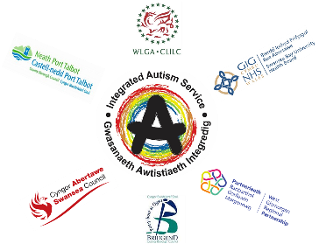

Western Bay Integrated Autism Service (WBIAS)
Virtual Autism Advice Sessions
Appointments available to book (up to 30 minutes)

When? Every Thursday
What? This is an advice session to discuss anything autism related. Due to Covid19 these are currently being run via telephone or video call
What do I need? A telephone, or a SMART phone or laptop, webcam, secure internet connection
Who? Sessions are open to anyone 18+, in Swansea, Neath Port Talbot & Bridgend, with or without an Autism diagnosis, including those awaiting an assessment.
Who is it with? There will be two Wellbeing Support Workers from the WBIAS present
How? Phone 01639 862936 or email sbu.WBIAS@wales.nhs.uk to book

